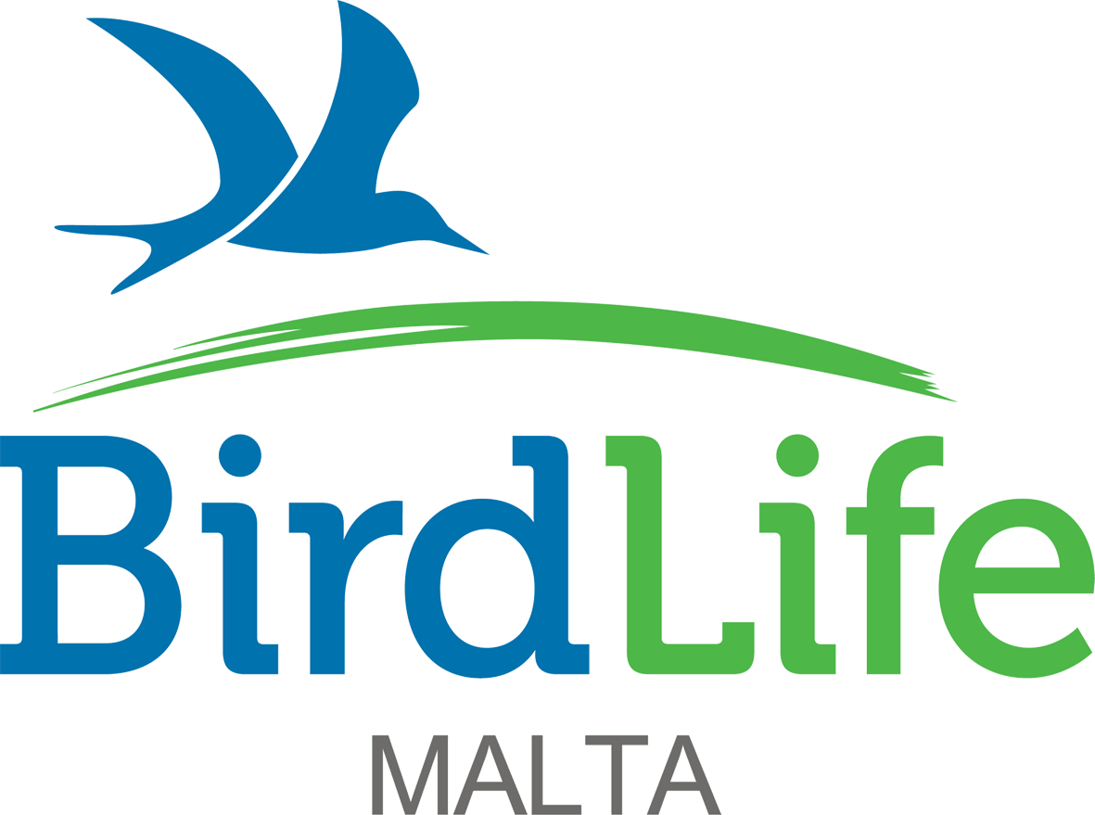
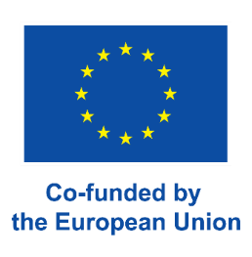
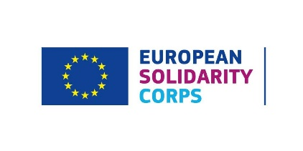

European Solidarity Corps 2025

New voluntary positions covering accommodation, expenses and allowance

We are looking for new full-time volunteers to join our international team protecting birds and their habitats and inspiring and educating people about birds and nature in the Maltese Islands. Volunteers will be based in our offices and at our nature reserves in Malta. Those who have previously participated in a long-term Erasmus+ European Voluntary Service (EVS) scheme or long-term Erasmus+ Volunteering scheme are not eligible to apply for these positions.

Are you:

- Aged 18-30
- A citizen of one of the programme or partner countries
- Outgoing, friendly, keen to meet new people, socialise, and experience a different culture
- Interested in improving bird, flora and other taxa identification skills
- Interested in inspiring and educating people about birds and the natural world
- Willing to develop administration, time management, numeracy, and interpersonal skills
- Willing to learn and having an adaptable approach in line with the needs of a charitable organisation’s structure including working flexible and occasional long hours, which could include weekends and public holidays.

The European Solidarity Corps programme will provide you:

- Accommodation close to our offices in Ta’ Xbiex/in the northern part of the island close to our nature reserves, or with host families
- Utilities such as electricity, water, gas, and internet
- Reimbursement of the flight and other transport costs (bus, train, metro) to/from Malta, limited according to distance
- €380 monthly allowance
- Private HEALTH insurance provided by Henner

CONSERVATION

Position: Conservation Assistant (1 position)
Dates: 1st July 2025 – 1st May 2026 (10 Months)

The Conservation department is looking for a candidate to assist the department in fulfilling a number of duties related to our core conservation work.

We are looking for motivated individuals:
- Having experience or knowledge in any of the following disciplines: biology, zoology, ecology, geography, environmental sciences
- Having experience or a background in wildlife crime work and/or rehabilitation of wildlife
- Having a hands-on approach to current conservation challenges in Malta, and are willing to work round the clock and occasionally during weekends from office to field
- Ideally having a valid driving licence.

The chosen candidate will fulfil the following role:

Bird rescue and care
BirdLife Malta runs a 24/7 voluntary injured bird recovery scheme, answering calls made by the public who encounter shot or injured birds in their property or in the countryside.

Accordingly, assistance is required in picking up and ensuring injured birds brought to BirdLife Malta receive urgent veterinary attention, and are rehabilitated with the aim of releasing them back into the wild. Duties will include:

- Answering calls by the public, picking up and ensuring injured birds brought to BirdLife receive urgent veterinary attention and first aid
- Feeding and caring for injured birds requiring short or long-term rehabilitation through various stages in their recovery so they can be released in to the wild
- Ensuring excellent hygiene to minimise health risks to birds and humans
- Providing feedback to people calling BirdLife Malta regarding injured bird cases
- Keeping records and case files of all cases of injured birds, reporting to Conservation Manager, Conservation Officer and veterinary surgeons on all cases of wild birds under our care
- Establishing and innovating feeding protocols, care and maintenance of injured birds ensuring they can be released at their outmost physical form.

COMMUNICATION (2 positions)

Position: Communication Assistant (1 position)
Dates: 1st April 2025 – 31st January 2026 (10 Months)

The Communication Assistant will assist in raising the profile of the organisation and its work through a variety of activities. Applicants are expected to have an interest in nature and the environment. The chosen applicant should have a good command of English. Proficiency in the use of Mailchimp is a must. The volunteer will report directly to the Public Engagement Executive and will have the following duties:

- Online Media: coordinating content and updating the BirdLife Malta website with news and blog content using WordPress
- Social Media: planning, implementing and uploading content for other social media including Facebook, Instagram, Bluesky, X, TikTok, LinkedIn, YouTube Channel and others
- Internal Communications: collating, writing and sending (using Mailchimp) monthly internal and external e-newsletter
- Magazine: coordinating and writing content for the BirdLife Malta quarterly magazine
- Press and Media: helping in drafting and distribution of press releases to the media, and supporting the Public Engagement Executive in generating coverage across traditional and new media to raise the profile of BirdLife Malta and its work
- Monitoring and Archiving:
- monitoring press coverage and managing the media coverage archive (online, print and video) together with compiling monthly statistics/reports of issued press releases and press coverage return;
- monitoring and writing monthly reports and statistics for social media and web activity, and
- compiling monthly e-newsletter Mailchimp report
- Other media work: working with project manager(s), conservation, education and fundraising staff to develop and implement targeted project and campaign communications for online, print and broadcast media.

Position: Photography & Film Production Assistant (1 position)
Dates: 1st July 2025 – 30th April 2026 (10 Months)
The Photography & Film Production Assistant will assist in raising the profile of the organisation and its work through a variety of activities. Applicants are expected to have an interest in nature and the environment. The chosen applicant should have a good command of English. Knowledge of InDesign, Adobe Premiere and Photoshop is a must. The volunteer will assist the Design & Digital Media Officer and will report directly to the Public Engagement Executive, fulfilling the following duties:

- Attend public and press events as a photographer/videographer
- Edit photographs using Photoshop to be used in internal and external
communication
- Produce and edit high quality video content for local and international audiences using Adobe Premiere Pro
- Play a key role in BirdLife Malta’s migration camps (Spring Watch and Raptor Camp) by downloading and organising photos and footage from the conservation team and creating videos to distribute to the media
- Manage video uploads and channels
- Archive, organise and upload multimedia content to the digital media library
- Assist in the design of BirdLife Malta’s printed materials including promotional leaflets, banners, logos and educational materials
- Assist in the design of BirdLife Malta’s printed magazine using InDesign
- Assist in the design and production of graphics and visuals for website, social media and advertising.

LAND MANAGEMENT (NATURE RESERVES) 4 positions

Position: Nature Reserves Visitor Assistant (4 positions)
Dates: 1st position: January 2025 – October 2025 (10 months)
2nd – 4th position: September 2025 – June 2026 (10 months)

In this role you will assist in the opening of the reserves to the public, working and ensuring visitors enjoy a pleasant experience. The chosen applicants will work at our nature reserves (Għadira, Simar, Foresta 2000 and Salina) reporting to the Site Warden and Head of Land Management. Training on the history of the sites and the flora and fauna of the reserves will be provided. Duties will include:

- Assisting in opening BirdLife Malta’s nature reserves to the public in the afternoon/evening, including on weekends.
- Setting up the display within the reception centre at the reserves
- Preparing the nature shop at the reserves
- Setting up binoculars before the reserve opening hours
- Greeting visitors at the reserves and giving a basic explanation about the nature reserve, its history, flora and fauna
- Managing a small shop and promoting sales whilst encouraging membership to BirdLife Malta
- Compiling visitor statistics and gathering feedback from visitors
- Participating in regular events held at the nature reserve with the aim of educating visitors towards more environmental appreciation.
- Taking visitors around the reserve, which could entail walking on uneven terrain even during summer.
- Assisting in research work being carried out at the nature reserves.
- Helping with inputting data.
Should the reserves be closed to the public for certain periods, especially the summer months, the applicants are expected to report at the nature reserves in order to assist the managing warden in the implementation of the work plan for the site. Such work has a physical aspect relating to the upgrade and maintenance of the habitat, as well as an element of research with ongoing studies on the flora and fauna of the sites.

TO APPLY

Please download and fill in the application form, making it clear which department or position you are interested in. Completed applications should be returned to info@birdlifemalta.org with subject: Application for European Solidarity Corps (Position) e.g. Application for European Solidarity Corps (Conservation Assistant).

We highly recommend that you visit our website on www.birdlifemalta.org for further information before applying.

Applications close on Saturday 25th January 2025 at 23:00 GMT. Zoom/Skype interviews will take place shortly afterwards. Please note that incomplete and/or late applications will not be taken into consideration.

